OUR FIVE SENSES

Dear Parents,

First off, thank you for being willing to partner with me to help your child grow and learn all that they can! This Reading Suitcases will focus on developing your child’s understanding of the five senses that each of have and use every day.

In this backpack, there are three books about the senses for you to read with your child. In each book, I have placed sticky notes on various pages with specific questions for you ask your child as you are going through the book. I highly recommend you asking these questions as you read. This method of questioning allows your child to build a habit of active listening, where they aren’t simply hearing the story, but processing the information found within its pages.

I have also included four different activities in this suitcase to go along with the books. These activities work to improve your child’s reading, writing, math, and science skills in addition to the language development you are helping them with! It is my goal to collect all of the completed activities for each student, if possible!

Thank you so much for wanting to do all that you can to allow your child to thrive!

Sincerely,
Mrs. McGuire
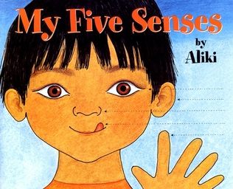
My Five Senses

By Aliki

- Do you know what any of your senses are? (Cover page)
- What is the best thing to taste with your tongue? (Page 10)
- What are some things that you hear when you’re at school? (Page 16)
- There are a lot of cookies on this page. What shapes do you see? (Page 17)
- What senses did you use while we were reading this book? (Page 32)
The Very Hungry Caterpillar

By

Eric Carle

- What do you think is in the little, white egg? (Page 1)
- Do you think you could get full after eating only one apple all day? (Page 6/Apple Page)
- The caterpillar ate apples, pears, plum, strawberries, and oranges. What other kinds of foods taste good with fruit? What foods or drinks can you make with fruit? (Page 10)
- What is your favorite thing to eat and why? (Pages 11-12)
- If you ate only sweet foods, what do you think might happen? What do you think is going to happen to the caterpillar? (Page 12)
- The caterpillar made a cocoon and lived in it for a while, like a house. But the story says he nibbled his way out. If you eat your house, what would you want your house to be made of? (Page 16)

Brown Bear, Brown Bear, What Do You See?

By

Bill Martin Jr. and Eric Carle

- Can you guess what animal the Brown Bear sees first? (Page 1)
- What do you think of all the colors these animals are so far? Have you ever seen a blue horse, purple cat, etc. before? (Page 11)
- Are there any animals we have read about that look like animals you’ve seen in real life? Which ones? (Page 17)
- What colors do you see on the pages with the teacher? (Pages 19-20)
- Where do you think all of these animals live? (Pages 23-14)

Reading Activity

After reading My Five Senses by Aliki, you and your your child should complete a sorting game! For this activity, you and your child will need to sort the following items into categories based one what sense they use for it. Your job will be to cut out the sorting cards and lay out the headings (See, Smell, etc.) for the child. Then you can take turns picking an item and placing it in a category! The goal of this activity is not necessarily for accuracy, but to generate conversation. If your child thinks that the picture of pizza needs to go in the Smell Category, that’s fine! As long as they can provide a reason they think the way do. I have included 30 items to sort, as well as the five headings. Feel free to use as many or as few as you want!
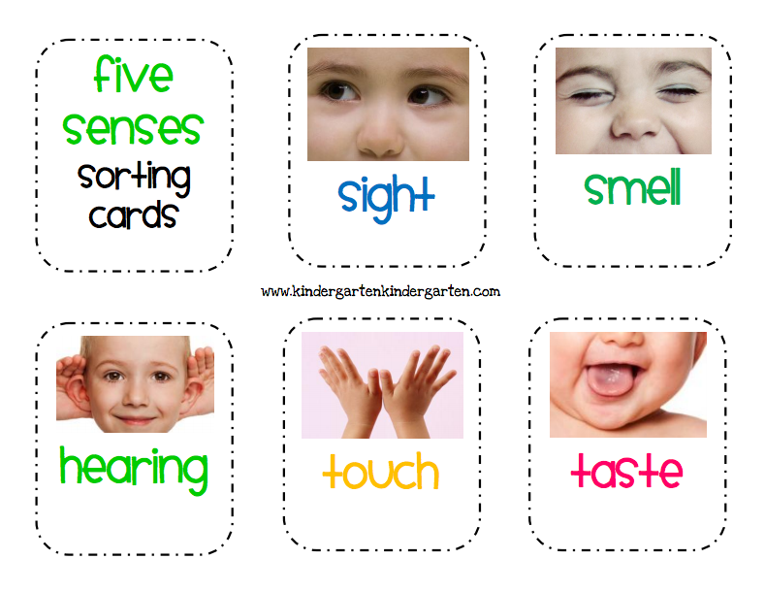
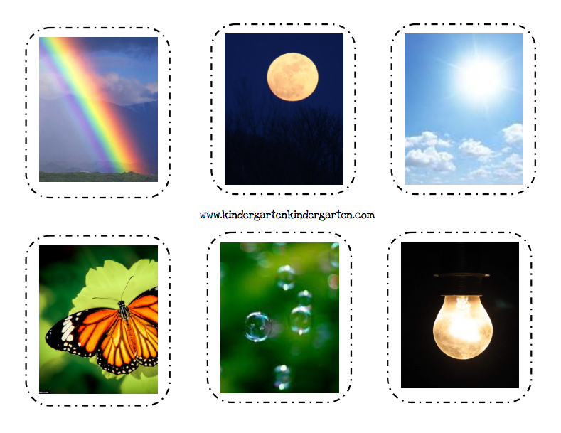
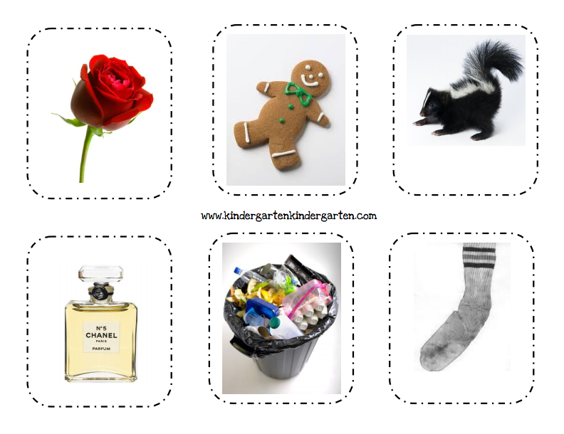
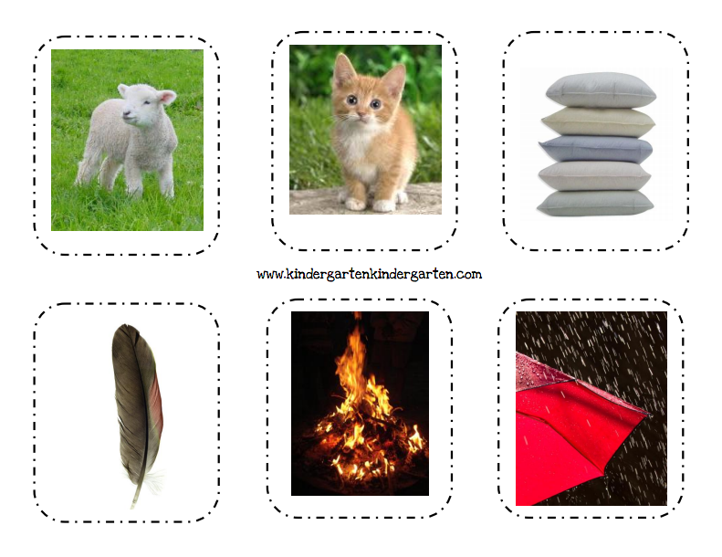
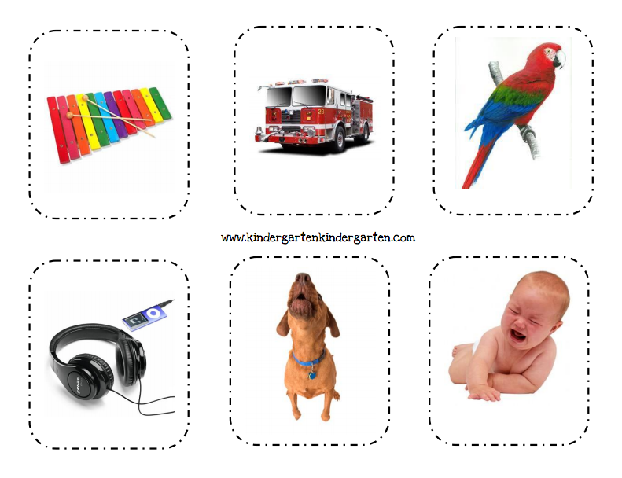
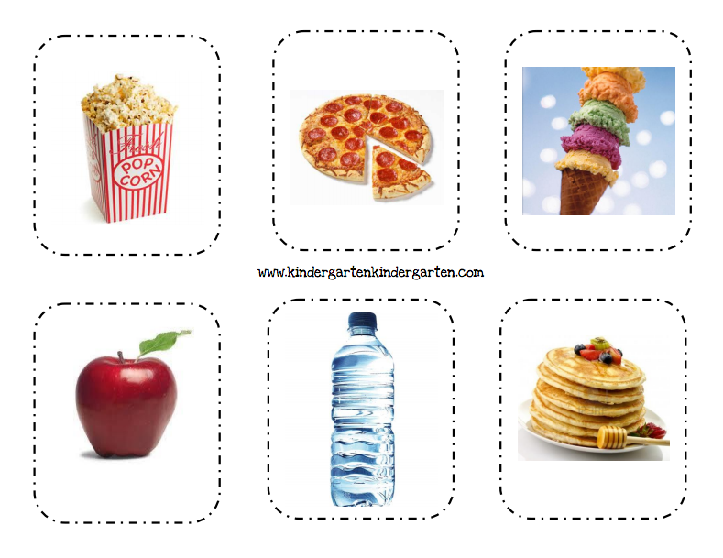
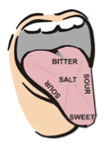
Science Activity

For this activity, you will need:
Something Salty (pretzels, salt, etc.)
Something Sweet (a fruity candy)
Something Bitter (unsweetened cocoa)
Something Sour (lemon juice)

We read in My Five Senses that we use our tongue to taste. Take a look at the picture of the funny tongue above. Do you see how it is labeled with different words? That’s because different parts of your tongue can taste different things! Stick your tongue out. Touch the very tip of it. That’s where you taste sweet things. Touch the sides of your tongue. This is where you taste sour things. Touch the back of your tongue (but don’t choke yourself!). That’s where you taste bitter foods. Now touch the center of your tongue. That’s where you can taste salty foods. To help you remember all of that information, we’re going to do an experiment! You are going to taste each of the four foods in front of you, and so are your parents! Make sure you taste them ONE AT A TIME! See if you can feel where you taste the foods on your tongue!

(Parents, feel free to snap some pictures of your child’s reactions to the foods and send them to me!)
Writing Activity

For this activity, your child will need to either draw picture or find and cut out a magazine picture of something that they like to see, hear, touch, smell, and taste! They should cut and paste their pictures or color their drawings in the box designated for each sense. Then they fill in the rest of the sentence at the bottom of the page with their favorite thing to see/hear/smell/taste/touch.
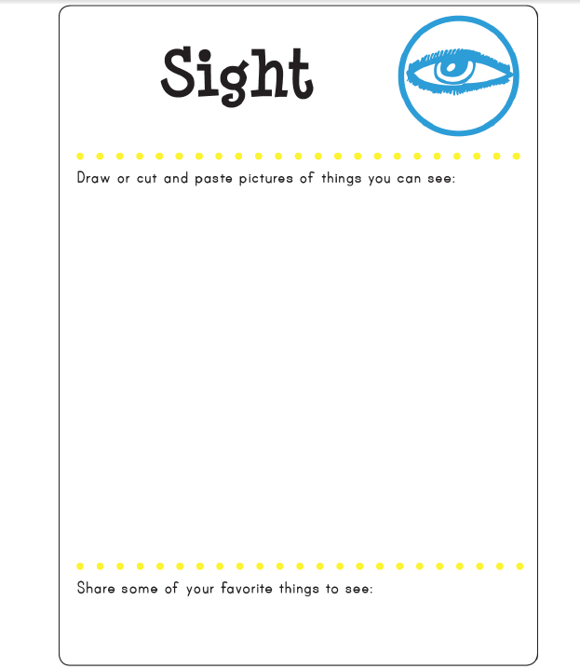
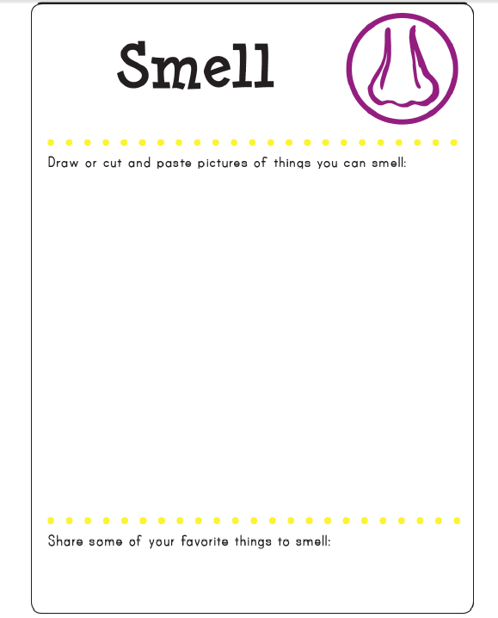
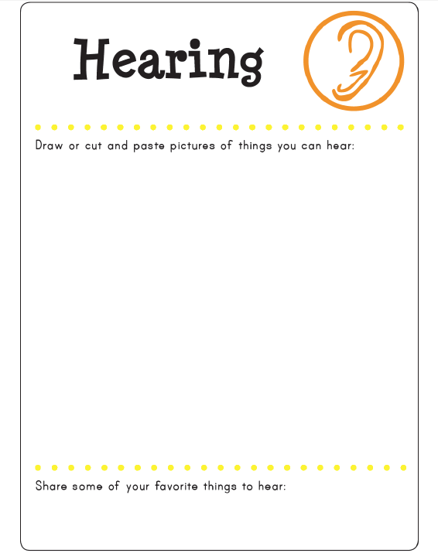
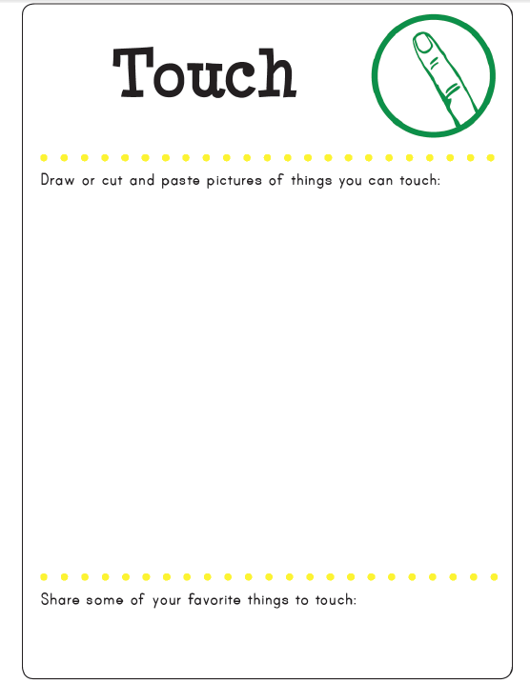
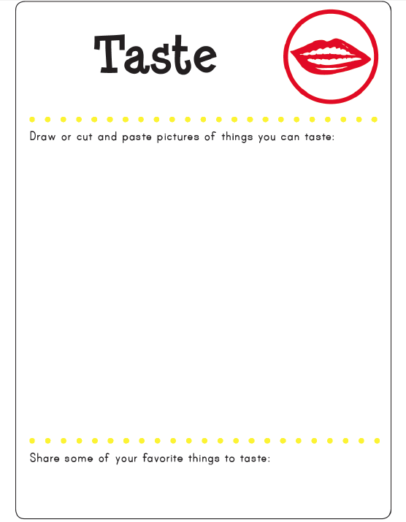
Math Activity

Please feel free to guide your child as they give their best attempt at answering theses math questions!

- How many senses do you have?

- In The Very Hungry Caterpillar, the caterpillar eats many different foods. Can you count how many kinds of foods he eats?

- How many animals can you count in Brown Bear, Brown Bear, What Do You See?

- When the little boy in My Five Senses plays with his puppy, how many senses is he using?

- When you play with your family, what senses do you use?

Dear Parents and Student,

Thank you so much for working with me and taking this journey together! I hope you learned some new things and that you had lots of fun! I’m very excited for you to come into class in the morning to tell me all of things you learned and what your favorite thing about this Reading Suitcase was, student!
When you are finished, please make sure everything in this Reading Suitcase finds its way back to me at school! I want to make sure I can see all of the great work you’ve done and I want to be able to send all of these books and activities home with another student so they can learn all of the cool things that you did!

See You in Class!
Mrs. McGuire

