A Day in the Life of the Shawnee Indians

Today we are going to explore what life as a Shawnee Indian looked like in 1800s. We will read about their history, see where they used to live in Ohio, hear what their language sounded like, learn about their different houses, and see what kinds of clothes they wore. You will read each stop and click on the provided links to view articles, watch a video, and see pictures and maps.

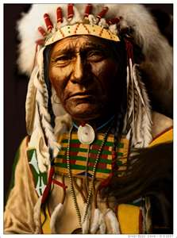

While on our adventure today, you will have to fill out your Travel Guide that has been printed out for you.

- Our first stop is going to teach you a little bit about the history of the Shawnee. Click HERE to find out more!

After reading this article, make sure you answer the background questions in your Travel Guide so you can remember some important facts before moving on.

- To see a map of where the Shawnee tribe used to live, click HERE. Using the knowledge you have about Ohio already, can you tell if there used to be any Shawnee Indians where we live today?

- The next stop is a VIDEO. Listen to Shawnee Elder Ron Hatten talk about some words we use today that came from the Shawnee language.

After you watch the short video, I want you to view THIS PICTURE GLOSSARY of different Shawnee words. What do you notice about the words under each picture? Do they look like our words? What is different about them? Write your observations in you Travel Guide after answering the question in it.

- Stop Number Four: Shawnee Houses. The Shawnee people lived in what is called a wigwam. They were shaped like a dome, a cone, or a rectangle with a curved roof. Take a look at this picture below.

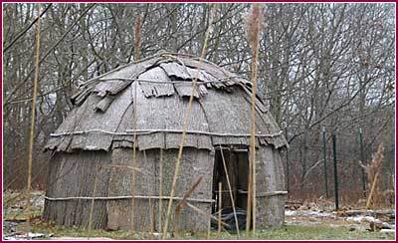

What does it looks like? Why do you think the Shawnee lived in these kinds of house instead of houses like we live in today? Write a bullet point list of your observations and 2-4 sentences about why you would or would not want to live in this kind of house in your Travel Guide.

- Our last stop is about the clothing the Shawnee wore. When you are reading the article, be thinking about what their clothes are made out of, how long it might have taken for the people to make their clothes? What about your own clothes? How are your clothes different from Indian clothing?
Click HERE to access the website and see the pictures.

TRAVEL GUIDE:
A DAY IN THE LIFE OF THE SHAWNEE INDIANS

As you explore the different websites about Shawnee Indians, fill out the corresponding questions for each stop.

Stop One:

- Which Indian tribe always threatened the Shawnee?

- Who was Tecumseh? Write two sentences describing him.

Stop Two:
- How many triangles are on the map of Ohio? What do they represent?

- Are those triangles at the top (North), in the middle, or more toward the bottom of the state (South)?

Stop Three:

- In the video, did you recognize any words Elder Hatten said that we use today? List at least two.

- Using the picture glossary, write the Shawnee word for the following:

  - DOG:

  - HORSE:

  - RACCOON:

  - OWL:

Stop Four:

- Write a bullet point list of your observations of the wigwam in the picture.

- Write 2-4 sentences about why you would or would not want to live in this kind of house.

Stop Five:

- What did the Shawnee Indians use to make their clothes? Why do you think they used this material?

- What differences did you notice when you compared the Indian clothing to your own clothing?

